Appendix B. Transport model outputs and validation

This appendix reports the aggregate forecasts and validation results for the year 2010 and 1990 in Boston metropolitan area. The models are estimated for 1990 and 2010 respectively (see Appendix A GREATER BOSTON TRANSPORT MODEL SPECIFICATION AND ESTIMATION). The population data come from 1990 and 2010, mostly from CTPP (Census Journey-to-Work) data.

[Contributors: Yafei Han, Shenhao Wang]

# 2010 model

## Vehicle ownership (VO)

Table – Predicted and Observed Vehicle Ownership Shares (Year 2010)

|  |  |  |  |  |  |  |
| --- | --- | --- | --- | --- | --- | --- |
|  | Model predicted |  | Observed (NCDB) |  | Observed  (CTPP) |  |
|  | HH | % | HH | % | HH | % |
| 0-veh | 201,957 | 12.0 | 227,120 | 13.4 | 201,916 | 13.4 |
| 1-veh | 555,660 | 33.0 | 597,566 | 35.4 | 555,619 | 35.4 |
| 2-veh | 629,302 | 37.4 | 621,787 | 36.8 | 629,108 | 36.8 |
| 3-veh | 295,663 | 17.6 | 243,061 | 14.4 | 295,396 | 14.4 |
| Total HH | 1,682,584 | 100.0 | 1,689,534 | 100.0 | 1,682,038 | 100.0 |

Note that TAZ accessibility input is updated after each iteration loop.

NCDB: Census Neighborhood Change Database 2010.

## Trip generation (TG)

### HBW trips

Table – Workers and Jobs by Earnings in 2010

|  |  |  |  |  |
| --- | --- | --- | --- | --- |
| Worker’s earning | Workers | % | Jobs | % |
| Earn1 (<25K) | 590,978 | 27.9 | 669,849 | 28.2 |
| Earn2 (25-50K) | 613,708 | 28.9 | 678,366 | 28.5 |
| Earn3 (50-75K) | 445,771 | 21.0 | 473,170 | 19.9 |
| Earn4 (75-100K) | 231,151 | 10.9 | 236,260 | 9.9 |
| Earn5 (MT100K) | 239,805 | 11.3 | 320,328 | 13.5 |
| Total | 2,121,416 | 100.0 | 2,377,973 | 100.0 |
| (CTPP Total) | (2,208,318) |  | (2,378,383) |  |

Note: Computed from HH224 input table using a dictionary that translates HH-income to worker-earning. Dictionary is generated based on PUMS data.

**HBW Output Summary**

* Total HBW Trips 2,684,725
* Total HBW Captive Trips: 129,895 (workers from 0-veh HH)
* Total HBW Choice Trips: 2,554,829
* HBW Trips/Worker: 1.27 (this includes workers who work at home)

Table – HBW Trip Production and Attraction by Income Category in 2010

|  |  |  |  |
| --- | --- | --- | --- |
| Worker’s earning levels | P_HBW TOTAL | P_HBW_CHO | P_HBW_CAP |
| Earn1 (<25K) | 740,456 | 679,033 | 61,423 |
| Earn2 (25-50K) | 785,026 | 746,677 | 38,349 |
| Earn3( 50-75K) | 569,975 | 552,362 | 17,613 |
| Earn4 (75-100K) | 291,841 | 285,020 | 6,821 |
| Earn5 (MT100K) | 297,428 | 291,738 | 5,689 |
| Total | 2,684,725 | 2,554,829 | 129,895 |

### Other trip purposes

Table – Trip Production and Attraction for Other Trip Purposes in 2010

|  |  |
| --- | --- |
| Purpose | Production==Attraction |
| HBSC | 938,961 |
| HBPUDO | 1,352,788 |
| HBSH | 1,475,053 |
| HBBPB | 1,485,402 |
| HBSO | 765,194 |
| HBEAT | 583,788 |
| HBREC | 1,155,633 |
| HBO | 72,793 |
| NHBW | 1,422,591 |
| NHBO | 2,526,583 |

## Trip distribution (TD)

Table – Predicted vs. Observed HBW flows (Town level including Boston)

|  |  |  |  |  |  |
| --- | --- | --- | --- | --- | --- |
|  | b | b0 | R_sq | p-value | std_err |
| Earn1 | 1.230 | 0.765 | 0.993 | 0 | 0.00092 |
| Earn2 | 1.225 | 2.091 | 0.991 | 0 | 0.00102 |
| Earn3 | 1.322 | 1.261 | 0.985 | 0 | 0.00143 |
| Earn4 | 1.468 | -0.075 | 0.977 | 0 | 0.00197 |
| Earn5 | 1.006 | 0.519 | 0.976 | 0 | 0.00136 |

Table – Predicted vs. Observed HBW flows (Town level without Boston)

|  |  |  |  |  |  |
| --- | --- | --- | --- | --- | --- |
|  | b | b0 | R_sq | p-value | std_err |
| Earn1 | 1.152 | 2.252 | 0.928 | 0.000 | 0.00282 |
| Earn2 | 1.089 | 4.752 | 0.926 | 0.000 | 0.00270 |
| Earn3 | 1.145 | 3.665 | 0.894 | 0.000 | 0.00349 |
| Earn4 | 1.228 | 1.546 | 0.859 | 0.000 | 0.00445 |
| Earn5 | 0.927 | 1.269 | 0.883 | 0.000 | 0.00301 |

Table – Predicted vs. Observed HBW flows (TAZ level)

|  |  |  |  |  |  |  |  |
| --- | --- | --- | --- | --- | --- | --- | --- |
|  | b | b0 | | R_sq | p-value | std_err | |
| Earn1 | 0.677 | | 0.354 | 0.520 | 0.000 | | 0.001127 |
| Earn2 | 0.497 | | 0.503 | 0.561 | 0.000 | | 0.000743 |
| Earn3 | 0.404 | | 0.418 | 0.551 | 0.000 | | 0.000620 |
| Earn4 | 0.329 | | 0.233 | 0.483 | 0.000 | | 0.000605 |
| Earn5 | 0.227 | | 0.240 | 0.443 | 0.000 | | 0.000467 |

Earning groups: ['LT25K','25-50K','50to75K','75to100K','MT100K']

## Mode choice

Table – Observed Mode Shares for HBW in 2010

|  |  |  |  |  |  |
| --- | --- | --- | --- | --- | --- |
|  | **Total** | **inc1** | **inc2** | **inc3** | **inc4** |
| SOV | 71.9% | 56.0% | 65.1% | 70.5% | 75.4% |
| APAX | 8.3% | 10.3% | 9.8% | 9.0% | 7.7% |
| PT | 13.5% | 20.4% | 16.4% | 13.5% | 12.1% |
| BIKWALK | 5.5% | 11.6% | 7.6% | 6.0% | 4.2% |
| TAXIOTH | 0.8% | 1.7% | 1.1% | 0.9% | 0.6% |

Table – Predicted HBW Mode Shares in 2010

|  |  |  |  |  |  |
| --- | --- | --- | --- | --- | --- |
|  | **Total** | **inc1** | **inc2** | **inc3** | **inc4** |
| SOV | 74.6% | 59.9% | 74.9% | 76.9% | 77.1% |
| APAX | 4.4% | 4.8% | 4.4% | 4.2% | 4.5% |
| PT | 11.7% | 12.7% | 10.8% | 11.6% | 12.2% |
| WAT | 7.4% | 10.4% | 7.3% | 7.1% | 7.0% |
| DAT | 4.2% | 2.3% | 3.6% | 4.5% | 5.2% |
| WALK | 9.3% | 22.6% | 9.9% | 7.2% | 6.2% |

Table – Observed and Predicted Mode Shares for HBSHOP Trips

|  |  |  |  |  |  |
| --- | --- | --- | --- | --- | --- |
| **HBSHOP** | Population | Sample | Population  Share | Sample Share | Predicted  Share |
| SOV | 288,229 | 1,827 | **67.2%** | 71.1% | **49.3%** |
| Auto-pax | 80,928 | 436 | **18.9%** | 17.0% | **15.4%** |
| Transit | 24,271 | 116 | **5.7%** | 4.5% | **2.9%** |
| PNR | 581 | 5 | **0.1%** | 0.2% | **0.4%** |
| Walk | 35,183 | 184 | **8.2%** | 7.2% | **31.9%** |

Table – Observed and Predicted Mode Shares for HBO Trips

|  |  |  |  |  |  |
| --- | --- | --- | --- | --- | --- |
| **HBO** | Population | Sample | Population  Share | Sample Share | Predicted |
| SOV | 1,280,186 | 8,020 | 64.2% | 67.9% | 47.6% |
| Auto-pax | 458,572 | 2,577 | 23.0% | 21.8% | 17.6% |
| Transit | 116,382 | 490 | 5.8% | 4.1% | 2.4% |
| PNR | 6,312 | 38 | 0.3% | 0.3% | 0.7% |
| Walk | 131,844 | 691 | 6.6% | 5.8% | 31.6% |

Table – Observed and Predicted Mode Shares for NHBW Trips

|  |  |  |  |  |  |
| --- | --- | --- | --- | --- | --- |
| **NHBW** | Population | Sample | Population  Share | Sample  Share | Predicted |
| SOV | 813,479 | 5,311 | 75.0% | 77.9% | 62.7% |
| Auto-pax | 45,122 | 211 | 4.2% | 3.1% | 3.1% |
| Transit | 72,775 | 361 | 6.7% | 5.3% | 1.9% |
| PNR | 7,262 | 47 | 0.7% | 0.7% | 0.7% |
| Walk | 146,222 | 889 | 13.5% | 13.0% | 31.6% |

Table – Observed and Predicted Mode Shares for NHBO Trips

|  |  |  |  |  |  |
| --- | --- | --- | --- | --- | --- |
| **NHBO** | Population | Sample | Share | Share | Predicted |
| SOV | 1,066,215 | 6,634 | 60.2% | 64.0% | 47.1% |
| Auto-pax | 462,746 | 2,581 | 26.1% | 24.9% | 19.3% |
| Transit | 79,371 | 329 | 4.5% | 3.2% | 1.9% |
| PNR | 1,845 | 10 | 0.1% | 0.1% | 0.2% |
| Walk | 162,227 | 816 | 9.2% | 7.9% | 31.4% |

## Traffic Assignment

Table – Road Traffic Assignment Summary (2010)

|  |  |  |  |  |  |
| --- | --- | --- | --- | --- | --- |
| **24 HOURS** | **VMT** | **VHT** | **VHT_FF** | **SPEED** | **SPEED_FF** |
| Expressways (1-6) | 47,882,984 | 880,387 | 795,434 | 54.4 | 60.2 |
| Main Arterials (11-14) | 4,577,370 | 125,849 | 116,483 | 36.4 | 39.3 |
| Minor Arterials (15-18) | 15,364,175 | 563,375 | 543,282 | 27.3 | 28.3 |
| Main Distributors (20-21) | 11,405,104 | 466,016 | 456,215 | 24.5 | 25 |
| Minor Distributors (25-26) | 1,531,444 | 66,578 | 61,383 | 23 | 24.9 |
| Local streets (31) | 4,035,996 | 204,303 | 201,639 | 19.8 | 20 |
|  |  |  |  |  |  |
| **AM** | **VMT** | **VHT** | **VHT_FF** | **SPEED** | **SPEED_FF** |
| Expressways (1-6) | 3,586,599 | 66,954 | 59,410 | 53.6 | 60.4 |
| Main Arterials (11-14) | 334,082 | 9,091 | 8,332 | 36.7 | 40.1 |
| Minor Arterials (15-18) | 1,028,784 | 37,800 | 36,256 | 27.2 | 28.4 |
| Main Distributors (20-21) | 720,105 | 29,735 | 28,805 | 24.2 | 25 |
| Minor Distributors (25-26) | 108,526 | 4,787 | 4,350 | 22.7 | 24.9 |
| Local streets (31) | 237,296 | 12,032 | 11,846 | 19.7 | 20 |
|  |  |  |  |  |  |
| **MD** | **VMT** | **VHT** | **VHT_FF** | **SPEED** | **SPEED_FF** |
| Expressways (1-6) | 2,594,536 | 45,133 | 43,198 | 57.5 | 60.1 |
| Main Arterials (11-14) | 255,422 | 6,784 | 6,541 | 37.7 | 39 |
| Minor Arterials (15-18) | 877,159 | 31,674 | 31,058 | 27.7 | 28.2 |
| Main Distributors (20-21) | 663,029 | 26,810 | 26,522 | 24.7 | 25 |
| Minor Distributors (25-26) | 85,982 | 3,680 | 3,446 | 23.4 | 24.9 |
| Local streets (31) | 244,196 | 12,301 | 12,203 | 19.9 | 20 |
|  |  |  |  |  |  |
| **PM** | **VMT** | **VHT** | **VHT_FF** | **SPEED** | **SPEED_FF** |
| Expressways (1-6) | 4,752,689 | 92,845 | 78,874 | 51.2 | 60.3 |
| Main Arterials (11-14) | 451,373 | 13,140 | 11,568 | 34.4 | 39 |
| Minor Arterials (15-18) | 1,526,028 | 57,296 | 53,956 | 26.6 | 28.3 |
| Main Distributors (20-21) | 1,149,317 | 47,478 | 45,974 | 24.2 | 25 |
| Minor Distributors (25-26) | 150,449 | 6,805 | 6,030 | 22.1 | 24.9 |
| Local streets (31) | 402,222 | 20,539 | 20,097 | 19.6 | 20 |
|  |  |  |  |  |  |
| **RD** | **VMT** | **VHT** | **VHT_FF** | **SPEED** | **SPEED_FF** |
| Expressways (1-6) | 1,291,103 | 21,593 | 21,514 | 59.8 | 60.0 |
| Main Arterials (11-14) | 125,421 | 3,208 | 3,199 | 39.1 | 39.2 |
| Minor Arterials (15-18) | 442,780 | 15,721 | 15,690 | 28.2 | 28.2 |
| Main Distributors (20-21) | 332,305 | 13,309 | 13,292 | 25.0 | 25.0 |
| Minor Distributors (25-26) | 43,266 | 1,745 | 1,734 | 24.8 | 24.9 |
| Local streets (31) | 122,829 | 6,143 | 6,138 | 20.0 | 20.0 |

### Volume (V) and Volume/Capacity (V/C)

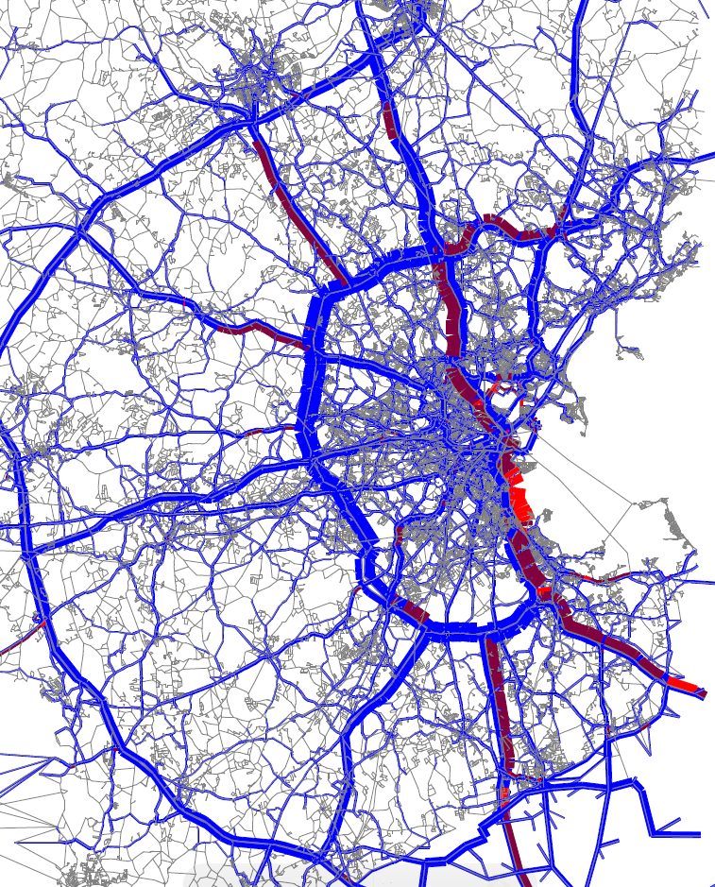

Figure ‑ AM Volume (V) and Volume/Capacity (V/C)

(Dark red: 1<V/C<1.5; bright red: V/C>1.5)

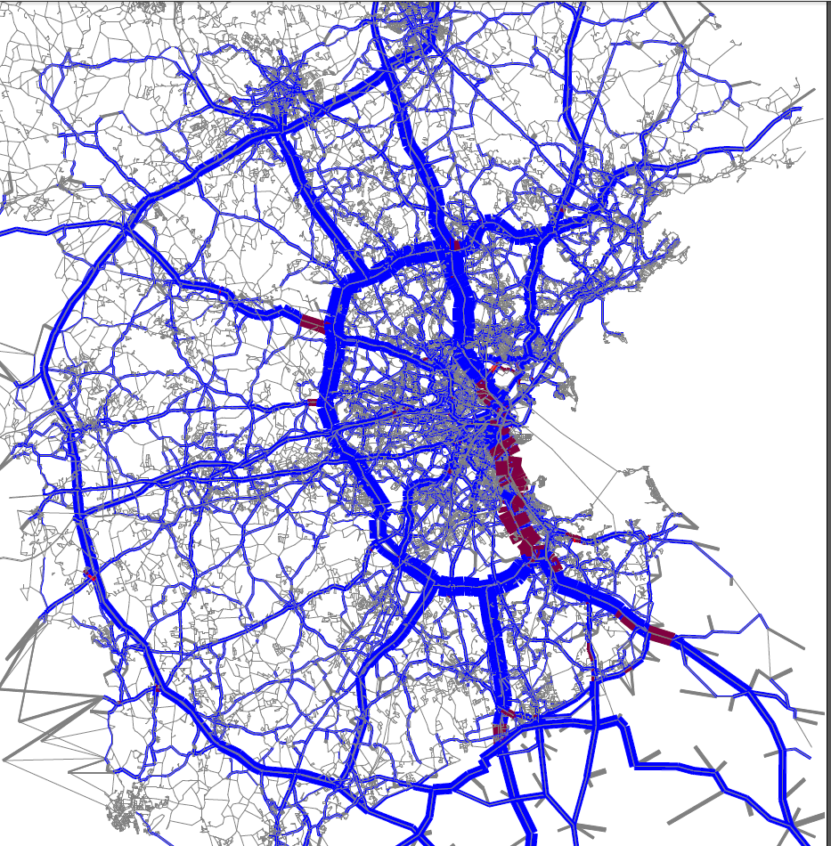

Figure ‑ Mid-day Volume (V) and Volume/Capacity (V/C)

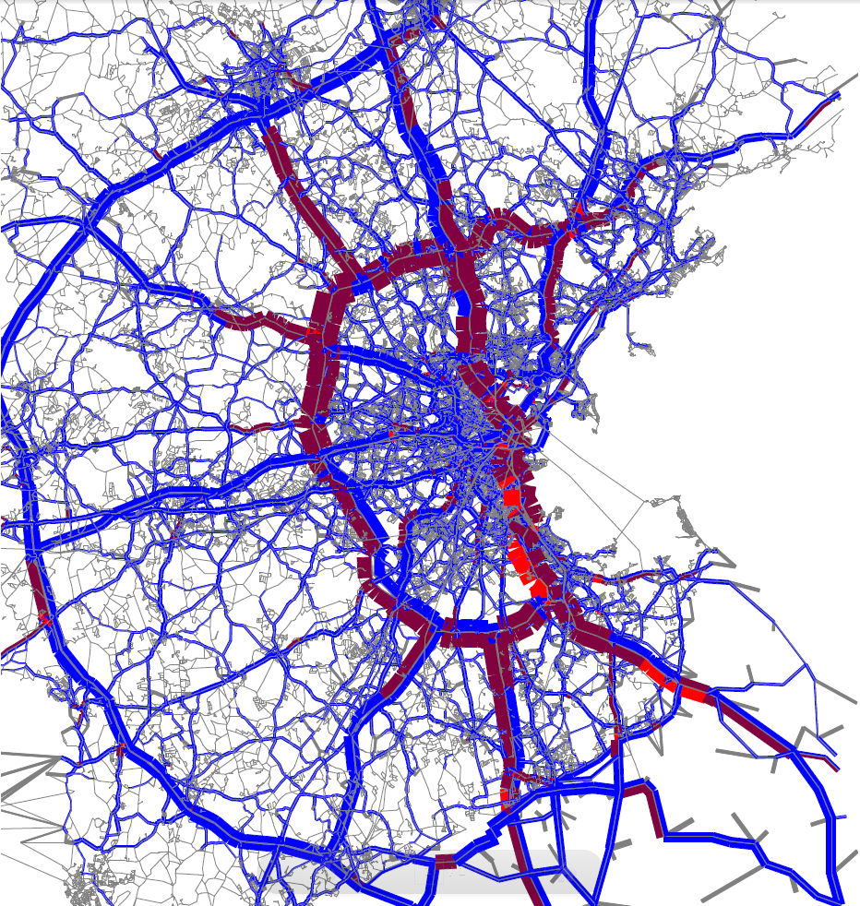

Figure ‑ PM Volume (V) and Volume/Capacity (V/C)

### Traffic Volume by Household Income

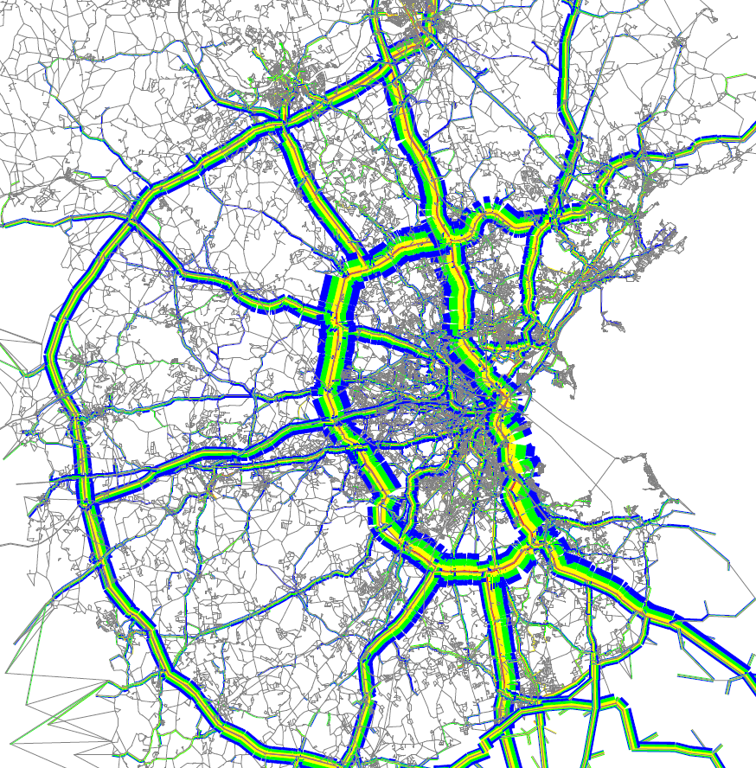

Figure ‑ AM Volume by Household Income

(Red: INC1; yellow: INC2; green: INC3; blue: INC4)

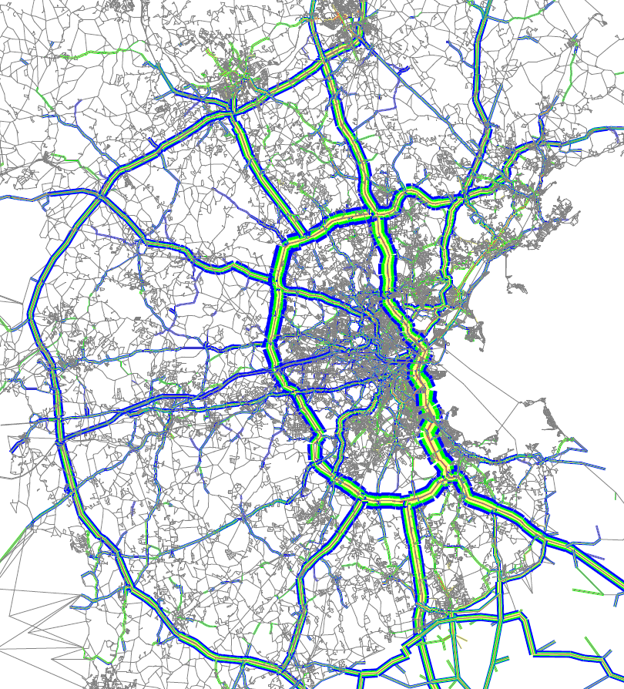

Figure ‑ Mid-day Volume by Household Income

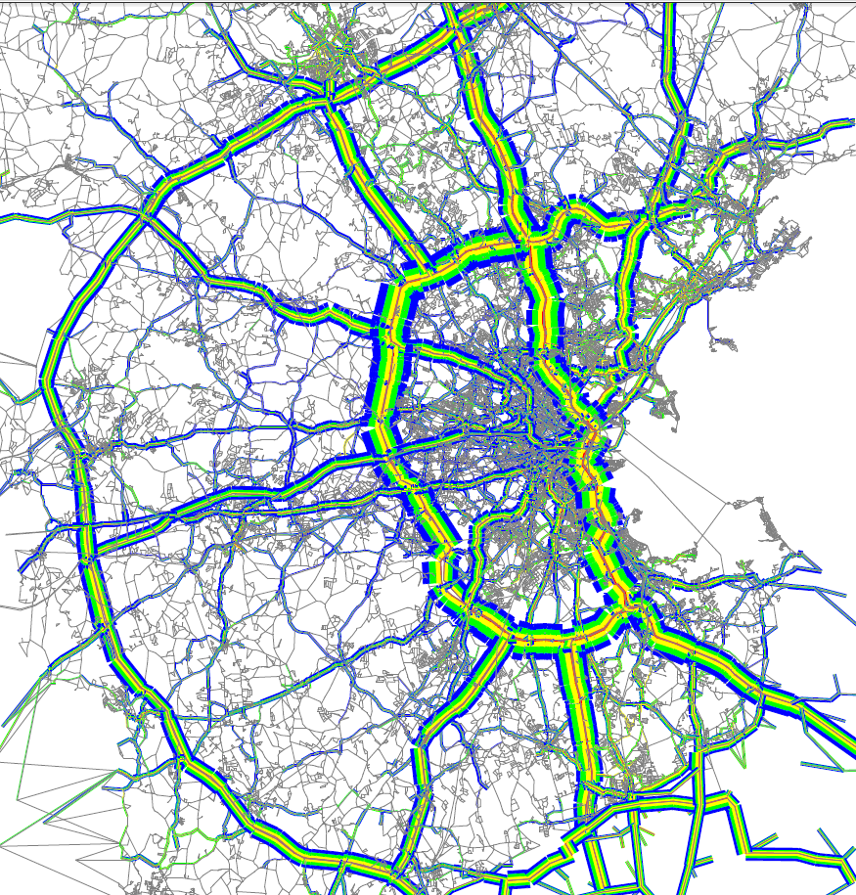

Figure ‑ PM Volume by Household Income

## Transit Ridership

Table – Observed and Predicted Transit Ridership in 2010

|  |  |  |  |
| --- | --- | --- | --- |
| **Transit lines** | **Blue Book 2010**  **Unlinked trips** | **Predicted** | **% diff** |
| Red | 241,603 | 263,779 | 9.2% |
| Orange | 184,961 | 237,141 | 28.2% |
| Blue | 57,273 | 63,789 | 11.4% |
| Green | 236,096 | 235,495 | -0.3% |
| Silver Line | 30,026 | 29,433 | -2.0% |
| Bus (including Trackless Trolley) | 344,014 | 504,585 | 46.7% |

Figure ‑ Observed and Predicted Daily Boarding for Red Line Subway Stations.

Figure ‑ Observed and Predicted Daily Boarding for Orange Line Subway Stations.

# 1990 model

## Vehicle ownership

Table – Predicted and Observed Vehicle Ownership Shares (Year 1990)

|  |  |  |  |  |
| --- | --- | --- | --- | --- |
| HH | Predicted |  | Observed |  |
| 0-veh | 179,272 | 12.1% | 225,788 | 15.2% |
| 1-veh | 597,538 | 40.5% | 533,275 | 35.9% |
| 2-veh | 515,482 | 34.9% | 524,363 | 35.3% |
| 3-veh | 184,751 | 12.5% | 202,021 | 13.6% |
| Total | 1,477,045 | 100.0% | 1,485,447 | 100.0% |

## Trip generation

### HBW trips

Table – Workers and Jobs by Earnings in 1990

|  |  |  |  |  |
| --- | --- | --- | --- | --- |
| Inputs | Workers | % | Jobs | % |
| Earn1 | 605,202 | 30.8 | 647,419 | 29.9 |
| Earn2 | 633,767 | 32.3 | 735,685 | 34 |
| Earn3 | 417,364 | 21.2 | 413,207 | 19.1 |
| Earn4 | 175,765 | 8.9 | 176,766 | 8.2 |
| Earn5 | 132,078 | 6.7 | 190,716 | 8.8 |
| Totals by earning | 1,964,178 | 100 | 2,163,794 | 100 |
| TAZ table totals | 2,001,671 |  | 2,193,132 |  |

Output Summary

* Total HBW Trips 2,916,824
* Total HBW Captive Trips 162,559
* Total HBW Choice Trips 2,754,264
* HBW Trips/worker 1.49

Table – HBW Production and Attraction in 1990

|  |  |  |  |
| --- | --- | --- | --- |
| P_HBW  (=A_HBW) | Total | Choice | Captives |
| Earn1 | 881,272 | 806,498 | 74,774 |
| Earn2 | 949,647 | 895,756 | 53,891 |
| Earn3 | 626,782 | 602,494 | 24,287 |
| Earn4 | 263,183 | 257,048 | 6,136 |
| Earn5 | 195,941 | 192,469 | 3,471 |

### Other trip purposes

Table – Trip Production for Other Trip Purposes (1990)

|  |  |
| --- | --- |
| Trips by Other Purposes | Trips |
| HBSC | 863,123 |
| HBPUDO | 1,168,082 |
| HBSH | 1,581,868 |
| HBBPB | 1,435,712 |
| HBSO | 883,436 |
| HBEAT | 552,373 |
| HBREC | 796,426 |
| HBO | 90,061 |
| HBOA | 3,758,008 |
| NHBW | 2,172,225 |
| NHBO | 2,376,092 |

## Mode choice

Table – Predicted Mode Shares for 1990

|  |  |  |  |  |  |  |  |  |  |  |
| --- | --- | --- | --- | --- | --- | --- | --- | --- | --- | --- |
|  | HBW | % | HBSHOP | % | HBO | % | NHBW | % | NHBO | % |
| SOV | 2049435 | 70.3 | 624692 | 39.5 | 1818828 | 36.9 | 1472931 | 67.8 | 809981 | 34.1 |
| APAX | 299466 | 10.3 | 750778 | 47.5 | 2417355 | 49.1 | 392318 | 18.1 | 1149774 | 48.4 |
| WAT | 135328 | 4.6 | 19684 | 1.2 | 67598 | 1.4 | 23377 | 1.1 | 49242 | 2.1 |
| DAT | 99925 | 3.4 | 3776 | 0.2 | 19093 | 0.4 | 7336 | 0.3 | 19340 | 0.8 |
| WALK | 332668 | 11.4 | 182936 | 11.6 | 603213 | 12.2 | 276260 | 12.7 | 347753 | 14.6 |
| Total | 2916822 | 100 | 1581866 | 100 | 4926087 | 100 | 2172222 | 100 | 2376090 | 100 |

## Traffic Assignment

Table – Summary of Traffic Assignment for 1990 Model

|  |  |
| --- | --- |
| VMT | 76,304,886 |
| VHT | 2,114,992 |
| VHT_FF | 2,001,395 |
| VMT_AM | 5,511,617 |
| VHT_AM | 151,988 |
| VMT_MD | 4,981,127 |
| VHT_MD | 135,515 |
| VMT_PM | 7,423,812 |
| VHT_PM | 213,731 |
| VMT_RD | 1,891,426 |
| VHT_RD | 49,696 |

## Transit Assignment

Table – Observed and Predicted Transit Ridership for 1990

|  |  |  |  |  |  |
| --- | --- | --- | --- | --- | --- |
|  | **Pass** | **PassDist** | **PassHr** | **Observed**  **Ridership** | **Error** |
| Bus & Trolley | 238,403 | 325,687 | 25,964 | 381,659 | -38% |
| Subway | 605,616 | 1,406,620 | 8,587 | 561,441 | 8% |
| Red line | 203,791 | 690,165 | 2,921 | 185,671 | 10% |
| Blue line | 54,837 | 112,855 | 631 | 45,798 | 20% |
| Orange line | 152,417 | 341,636 | 1,565 | 120,486 | 27% |
| Green line | 194,570 | 261,965 | 3,469 | 209,486 | -7% |
| Commuter rail | 130,793 | 1,699,821 | 14,359 |  |  |